Connor Kordes

Architecting with Information

Table of Contents

Motivation and Scope 2

Key Questions 2

The Approach to Information 3

The Problem Formulation 5

The Scenario 5

The Tool 6

Results 9

Future Research 14

Conclusions 15

Works Cited 16

# Motivation and Scope

It was only 50 years ago that humans started architecting methods to depart the Earth and enter the Cosmos. With this, many agencies also saw space as a vector to get a better picture of the earth – literally – and observe the earth in a way previously unimaginable. This was the realm of satellites and sensors. Although the beginning was primitive, attaching nice cameras to something that orbited the earth, it didn’t take long before specific orbits for specific purposes evolved and agencies realized they could put much more than just cameras on these satellites. In the matter of 50 years, instruments such as radar, lidar, signals systems, and multispectral imagers have all been explored in relation to space, helping the world gain a better understanding of itself as well as the government a better understanding of its adversaries.

While the government has played a large role in advancing satellites, it is also important to note that the structure they had established in creating these systems may have lent itself to rapid preliminary development, but now contributes to a plethora of stove piped systems – systems that often have sensors far beyond what is necessary to understand a target. This may not sound like a problem, but in the evolving domain of space there is a demand for more diverse, less sensor optimized constellations. This combined with limited resources to continue architecting such systems makes new heterogeneous constellations critical. This is the heart of what this research intends to explore. With such focused views, there has been little research into how more integrated constellations might be designed as well as little research that sheds light on the potential advantages of these constellations.

Furthermore, this research aims to explore these questions using multi-objective optimization tools and information theory. Information theory helps create a metric to compare sensors across different domains, while the multi-objective optimization tools explore the solution space of employing such a metric in pre-existing designs.

# Key Questions

While there is no clear path to take when addressing this issue, there are some key elements that drive future research. Again, past research has only compared information from a certain sensor across that specific sensor’s domain. It is not common to assess what value an optical sensor has compared to a signals sensor as there has been no clear reason for such research. However, if one is aiming to design heterogeneous systems, it is something that must be understood. With this, the first question comes to light: What is the utility of one piece of information versus another?

This is where research quickly spreads to many different paths. Some employ Bayesian networks to assess what the value of gaining one piece of information in relation to the entire problem (Ahmed and Pottie). However, this method quickly comes with complications, requiring one to create probability distributions for different sensors *a priori* leaving researchers with the same questions they started with. Other’s employ possibility theory that works well in combining optical sensing with analysts input, a question similar but not as complex as the one posed (Roux and Desachy).

One of the more attractive methods categorized different types of mission objectives, and then rated the different types of sensors among each objective with analyst supervision. While this method may seem foolproof as it compares the different information across different domains, it is not scalable, it does not remain sensor agnostic, and utilizes an opinion that comes with bias.

Furthermore, these methods have all contributed to a couple of necessities in future research. Assuming two different sensors collect information over the same target at the same time, there needs to be a method to weight the utility of one sensor’s information over another without the input of analysts and without a specific defined scenario known beforehand. This is a question at the heart of the issue and while there are some methods, they are not well understood or validated.

Once this is answered, there is one other key question that falls more in the domain of data fusion. This is what advantage does one piece of information provides to another observation, potentially boosting its value. This again is something largely addressed in the research of Bayesian networks; however one must create this value beforehand (Ahmed and Pottie). While there are methods to train Bayesian Nets it requires data sets to allow it to adjust probability distributions, however there is no clear data one could use to train such networks. Understanding this, this is a question a newly designed constellation might be able to answer dynamically. In other words, while this is a question that researchers want to answer from the ground, it might be something that the first constellations must adapt to while they are in space, and future constellations can be optimized upon beforehand rather than in space. Another possibility may lie in synthetic data – data synthesized to simulate real world data. This data could be relayed to fake sensors and used to create the probability distributions previously discussed.

For example, if a constellation was designed with a multitude of sensors whose inputs fed into a classification method. One could accurately store the classification accuracy with one sensor input and perform the same classification with multiple inputs allowing one to see the utility of added information from a nonbiased perspective. Moreover, this would effectively create a probability distribution which could be applied in Bayesian Networks that could be used to weight the utility of information of one satellite observation to another.

While the second question is interesting, this research is primarily concerned with looking at the first from a very basic sense and comparing it to pre-existing notions of constellations that are largely based on probability of access metrics of targets rather than these metrics combined with an information metric.

# The Approach to Information

As previously mentioned, to accurately design MULTI-INT constellations there needs to be a way to properly assess one piece of information compared to another. One of the best solutions came in the form of Information Theory. While this is a diverse field, some researchers sought to apply it specifically to satellite sensors. Robert Harney, a physicist working at the Naval Post Graduate School, recognized the “inability to quantify *a priori* the fraction of total recognition performance that a given sensor will contribute.” Instead, in designing a metric across sensor domains, he utilized the fact that “the quantity of information extractable from a sensors data is directly related to that sensor’s ability.” Furthermore, each information metric across the different sensor domains is based on the following corollaries and conjectures postulated by Harney.

1. (Conjecture) The ability of a single or multiple sensor to recognize a target is directly related to the total quantity of information that can be determined about this target regardless of the source of information
   1. (Corollary) Information obtained from multiple sensors is as useful as the same quantity of information obtained from a single sensor.
   2. (Corollary) Information obtained from non-imaging sensors is as useful as the same quantity of information obtained from imaging sensors.

These conjectures and corollaries allowed Harney to create an information metric for intensity, color, range, and polarization information present in images as well velocity and spectra information present in non-imaging sensors. Each metric sought to define the maximum amount of useful information a sensor could get on a target or the amount of resolution elements each sensor contributes and multiplying this by the amount of detail in each resolution element defined by the sensors signal to noise ratio. The final metric comes in the form that Harney calls a “Shannon Bit,” which is a unitless metric for information that allows one to compare sensors across domains.

This is not the first time such a metric has been used in a classification scenario. Christin Grönwall, Piet Shwering, Jouni Rantakokko, Koen Benoist and Rob Kemp, a team of electro-optical sensor researchers implemented this metric in an urban domain and saw some success. Thus, Harney’s paper, in conjunction with these researchers’ efforts to apply this to another domain, was used as a roadmap in implementing the metric into this model.

With this method, there are some clear pitfalls. The first lies in capacity. For each sensor, the information metric derived by Harney serves more as a capacity than as a utility metric. For example, a regular panchromatic sensor with a 10m resolution looking at a 300m x 300m ship may be able to separate the target into 900 resolution elements, but this is a maximum capacity. It is quite likely that when this sensor is over a target it is nighttime or it is cloudy so there is no useful information present. Again, this might be true and future models should account for the possible precariousness of data from a specific sensor but using this metric of capacity for each sensor across the different domains mitigates these affects.

Beyond the issue with capacity versus utility, Harney’s metrics are hard to define with sensors that are in no pre-existing orbit. For example, for a spectral imager, it is hard to define a spatial resolution at varying orbits that can be used to calculate the resolution elements per target if one only has the spatial resolution for the sensor at a specific orbit. Of course there are equations that govern the sensors spatial resolution in relation to its semi-major axis, however these prove complex and varying for each sensor. Furthermore, it becomes difficult to implement in a model. Additionally, Harney’s main metric to describe a resolution element’s amount of information is the signal-to-noise-ratio (SNR) of the sensor. This is another thing that is established once a sensor is at a specific orbit and varies for each sensor in relation to its specifications. More than this, SNR is something that is highly variable depending on the angle the measurement was taken at and the time of day the measurement was observed. While it is possible to define such relations, it is labor intensive and requires experts for each specific sensor type. Furthermore, this research made some simplifying assumptions to emulate the relationships between spatial resolution and SNR in relation to the satellites semi-major axis, but these assumptions do not capture potential high-level relationships that might cause a shift in results.

Finally, there should be one last clarification about Harney’s metric. It requires that one know some information about the potential target before it has been seen. For example, to gain an accurate metric of information for a specific sensor, one must know at the very least its rough dimensions in terms of length, width, and height; they must know if it has any color and or polarization information and how much this may differ from the color or polarization of its surrounding environment; they must know if it travels at a specific velocity range; and finally it is pertinent to know if the target gives off any signals and the possible frequency of the signals. Another reasonable qualm with this approach is the constant flux of targets. For one scenario a certain constellation might provide lots of information but prove useless to other differing scenarios. This is again a question that lends itself to future research. This research aims at looking at one specific scenario and the constellations that arise from this, but if one wants to create a truly dynamic heterogeneous system it becomes tantamount to create scenarios that both encapsulate current and future needs.

# The Problem Formulation

While it is important to note the simplifying assumptions so future research can work to mitigate them, it is hard to understand them without the problem formulation. Furthermore, the scenario will be described as well as the tools used to obtain results.

### The Scenario

As is the case with most new research, it is often helpful to start with a basic scenario that encapsulates the problem without oversimplifying. In this case, a basic merchant-pirate scenario was crafted that was isolated to one specific region. This scenario was chosen because it lends itself to obvious, varying characteristics that could be observed via satellite (Jakob). The merchant ships where then given associated measurements of 350m length, 15m width, a height of 58 m, a distinct color differing from the background, a velocity, and boolean for transmitting a signal. On the other hand, pirate ships had a faster velocity, a length of 13m a width of 3.5 a color different from the merchants and the ability to transmit the same signal additionally represented by a boolean.

With the targets established, a sensor list was also crafted based off commercial sensors. This included the following sensors: VNIR, SWIR, TIR, MISR, POSEIDON_3, MODIS, LIDAR, VHRI, HRMX. Each sensor had an associated value for the parameters necessary in the Harney Equations for information as well as a fixed field of view (FOV). These are noted in the tables below.

|  |  |  |  |  |  |  |  |  |  |
| --- | --- | --- | --- | --- | --- | --- | --- | --- | --- |
|  | **VNIR** | **SWIR** | **TIR** | **MISR** | **POSEIDON_3** | **MODIS** | **LIDAR** | **VHRI** | **HRMX** |
| Spatial Resolution (meters) | 15 | 30 | 90 | 275 | 600 | 250 | 45 | 1 | 2 |
| Range Resolution  (meters) | 0 | 0 | 0 | 0 | 0.5 | 0 | 7.5 | 0 | 0 |
| Velocity Resolution (m/s) | 0 | 0 | 0 | 0 | 0 | 0 | 2 | 0 | 0 |
| Velocity Range (m/s) | 0 | 0 | 0 | 0 | 0 | 0 | 30 | 0 | 0 |
| CNR | 0 | 0 | 0 | 0 | 50 | 0 | 50 | 0 | 0 |
| SNR Polarization | 0 | 0 | 0 | 500 | 0 | 0 | 0 | 0 | 0 |
| SNR Intensity | 175 | 200 | 200 | 500 | 700 | 500 | 200 | 200 | 400 |
| Bandwidth (um) | 0 | 0 | 0 | 0 | 0 | 0 | 0 | 0 | 0 |
| Number of Bands | 3 | 6 | 5 | 36 | 0 | 36 | 0 | 5 | 4 |

*All data obtained from CEOS Handbook and 2018 edition of Comprehensive Remote Sensing*

|  |  |  |  |  |
| --- | --- | --- | --- | --- |
| **FOV Name** | **Min Max Angle** | **Axis** | **Type** | **Sensors with this FOV** |
| Aster Nadir | 0.0-14.0 | 0.0, 180.0 | Cone | VNIR, SWIR, TIR, MISR |
| Poseidon_3 | 0.0-6.0 | 0.0, 180.0 | Cone | Poseidon_3 |
| MODIS | 0.0-59.0 | 0.0, 180.0 | Cone | MODIS |
| LIDAR | 0.0-14.0 | 0.0, 180.0 | Cone | LIDAR |
| VHRI | 0.0-3.0 | 0.0, 180.0 | Cone | VHRI |
| HRMX | 0.0-2.0 | 0.0, 180.0 | Cone | HRMX |

Again, it is important to note that these characteristics are largely dependent on the altitude of the satellite, however going along with the idea of information capacity, the best SNR is chosen for each satellite among the different bands and time of day while additionally selecting the best spatial resolution for each sensor at its already pre-defined orbit.

### The Tool

Now that the constants in the model are established, it is important to define what will be fluctuating in the model and how solutions will be chosen. We will start with genetic algorithms. Genetic algorithms use the conventional processes that govern evolution and apply them to complex, multi-objective problems (Ferringer, Clifton, and Thompson). There are a lot of different tools and research within genetic algorithms and rather than delve into this, it is more important to discuss the problem in the context of putting it into a genetic algorithm.

Genetic algorithms are an efficient way to quickly determine a solution space when there are many elements at play. Furthermore, in the world of satellite constellations, they have been a very effective method of exploring the wide range of possible constellations and determining the best ones for specific purposes (Ferringer, Clifton, and Thompson). The most critical part of a genetic algorithm is the gene. Just as it does in humans, genes determine the traits that one’s solutions will have. In the context of this problem, the solutions are satellite constellations. The traits that can fluctuate or the genes of the constellation include: the number of satellites in the constellation, the inclination of each satellite, the specific sensor on each satellite, the semi major axis of each satellite, the right ascension of the ascending node of each satellite, and the mean anomaly of each satellite. The most critical part of this model is including the set of sensors as a gene that can change for each satellite in the constellation. Many have designed constellations based on the other genes but never on the sensors.

After deciding what can fluctuate, there must be rules that govern what makes for a good set of traits and what makes for a bad set of traits. These are defined as objectives, traits of our solutions – satellite constellations – which one either wants to minimize or maximize. This is the area where one can see how some of the problems discussed in the previous section are combatted.

In this scenario, there are six objectives: probability of partial access of the worst satellite in the constellation for the shortest event duration, the worst satellite in the constellation’s probability of full access for the longest event, the total information available to the entire constellation (computed via the Harney Metric), the semi-major axis for the highest satellite in the constellation, the number of unique sensors present within the entire constellation (a measure of sensor variety), and the total number of satellites in the constellation. The following table shows each objective, the direction in which the genetic algorithm determines the best solutions, and the reason the objective was included.

|  |  |  |
| --- | --- | --- |
| Objective | Direction of Optimization | Objective Description and Justification |
| Probability of partial access of the worst satellite in the constellation for the shortest event duration | Maximize | The metric is the probability that the worst satellite has any overlap with the shortest event (a 15 min event). It is a well-defined metric typically used in designing constellations that optimizes access to targets. |
| Probability of full access for the longest event of the worst satellite in the constellation | Maximize | This metric is the probability that the worst satellite can see the longest event (2.83 hours) for the full duration during its orbit. This is made to be another metric that optimizes prolonged access to targets. |
| The total information gathered by the entire constellation | Maximize | This is the critical new metric being added to the model that will help assess solutions on the merit of the information they offer |
| Semi-Major Axis for the Highest Satellite | Minimize | Mentioned before, there is a clear tradeoff between resolution, SNR, and the semi-major axis. While there is no exact relation in the model for this tradeoff. Adding an object that seeks to minimize the semi-major axis serves as a preliminary method of encapsulating this tradeoff. |
| Number of Unique Sensors | Maximize | In this specific scenario, there are some imaging sensors that will always be chosen if one is simply trying to maximize information as they provide the most information in this context. In exploration of more diverse solutions, this objective adds a penalty for using the same sensor |
| Number of Satellites | Minimize | Finally, it is obvious that the more satellites one has, the more information they will obtained based on the nature of the function. Thus, this objective penalizes large numbers of satellites. |

Now that the model has been expanded upon, it is clearer pointing out some of the simplifying assumptions that have been made and how these might be handled in the future. As of now, minimizing the semi-major axis, maximizing the number of unique sensors, and minimizing the number of satellites are all ways of balancing some of the inherent tradeoffs within the total information function that provides the Harney metric. While these objectives do their job, they are by no means refined. What they hint at is a cost function. A function that takes in as parameters the resolution, FOV, altitude, and SNR of a specific sensor satellite pair and provides an accurate, realistic cost of having such a pair. This cost could then collapse all three of these objectives and provide a more tuned penalty to the different metrics in a sensor satellite pair. Thus, for future research, it is important creating a function that can create a realistic cost with certain satellite parameters. It would both produce more accurate results and decrease the complexity of the genetic algorithm. Although the approach this research has taken is not necessarily wrong, this correction could make it vastly more attuned.

# Results

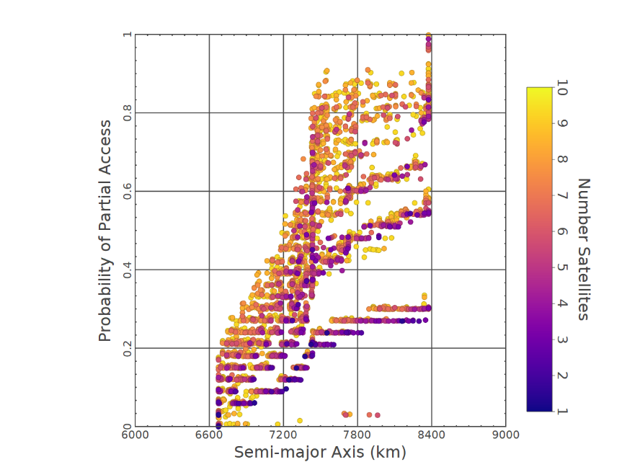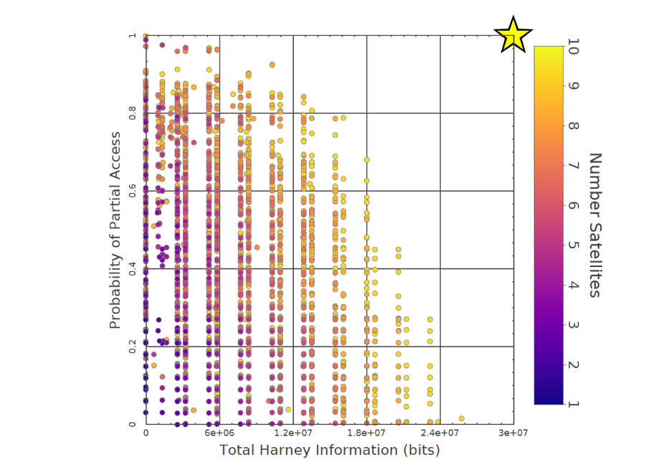 Once the problem is clearly defined, all that is left is to let the genetic algorithm find solutions along the Pareto frontier. With these solutions generated, the analysis can start. The most interesting results are posted below.

Figure 1: Probability of Access vs Semi-major Axis

Figure 2: Probability of Access vs Information Metric

Beginning with Figure 1, it is important to note some of the oddities of this graph as well as nuances in the metrics. Again, the probability of access metric is the probability that the worst satellite in the constellation has a chance of intersecting the event duration at any point. This is usually the metric that is employed for conventional satellite constellations, as access is typically correlated with the valuable information one will obtain. One can see hints at model confirmation as one would expect that as the semi-major axis increases and FOV stay constant there is an increase in the footprint of observing sensors, allowing satellites to see the target more often. Beyond this however, it appears that there are valuable solutions where there is a low probability of access and a large semi-major axis, hinting that there might be a tradeoff between information and the probability of access. Pulling these two metrics out separately in Figure 2, this exact tradeoff is highlighted. There is a clear utopia point among the two objectives in the top right corner as they both want to be maximized, but it also appears if someone seeks solely to maximize probability of axis, the top left solutions, then they will miss out on important information from the target. Thus, if one maximizes on the conventional objectives for heterogeneous systems, they are potentially overlooking a very important part of the constellation, the capacity of information it provides.

While this is an exciting incite from the current model, it is by no means complete. There were many simplifying assumptions made in a very basic scenario. If these complexities were included in a more dynamic model, than this conclusion might be more powerful, but as of now, there should be continued research in these fields, so these conclusions can be made with power in the data.

While the probability of access and information tradeoff is the highlight of this research, it also becomes interesting to look at families of solutions among the data and get a sense of how the model is generating solutions. Figure 3 investigates a subset of the GRIPS solutions with similar probability of access, altitudes, number of satellites and number of unique sensors on those satellites but with varying levels of total information (shown with color in Figure 3, orange having lower information and blue higher information). The last axis represents the sensors on each one of the satellites within the constellation and as one can see there is large variance in this metric as the different constellations often choose differing paths. While this is not a monumental conclusion, that different sensors provide different amounts of information, this method now allows one to isolate which sensor suites might be optimal for specific constellations objectives. This could be easily attained through minimal post processing of the solutions. Additionally, it confirms the model in that it shows that the information function is reliant on the sensors of the satellites, a foundational principle of the Harney metrics.

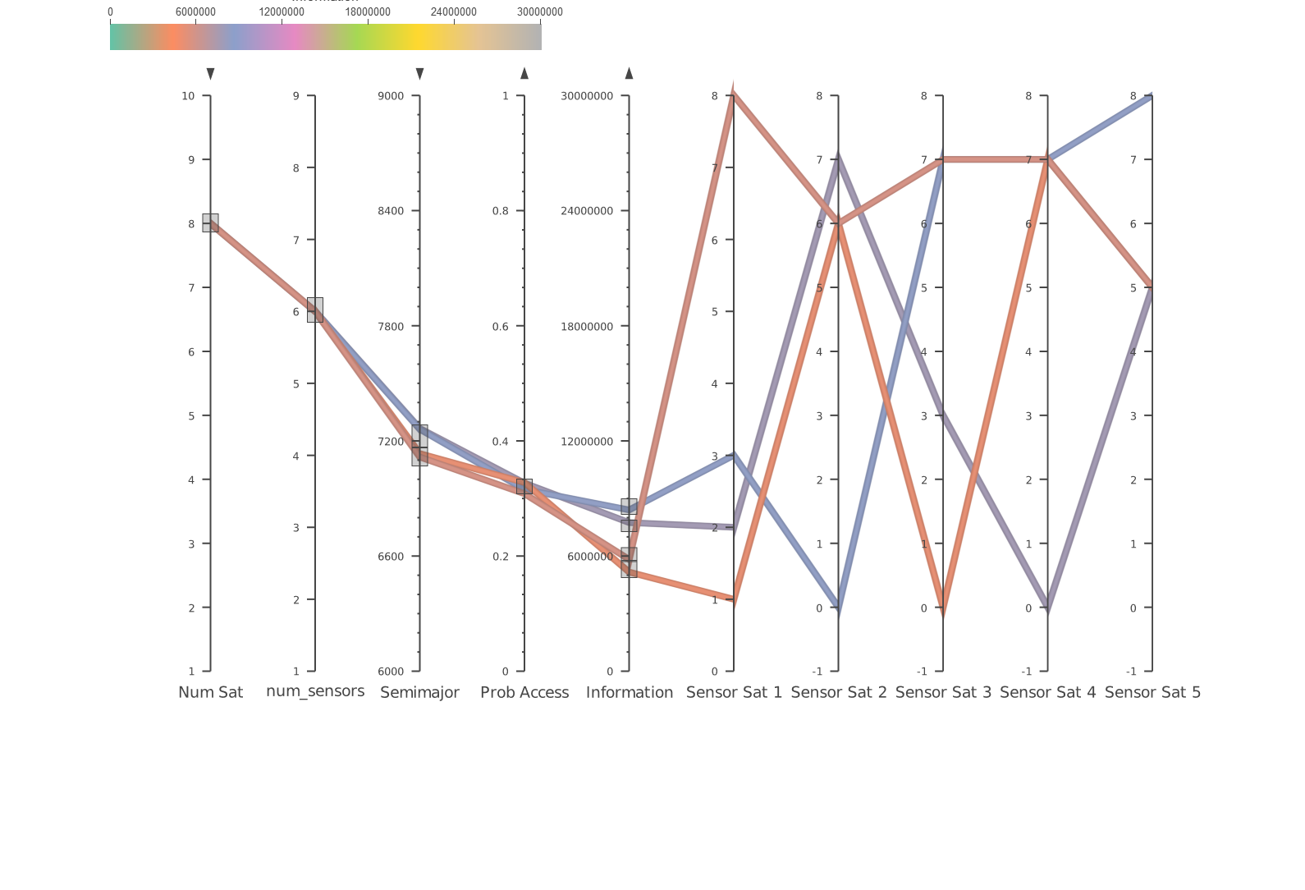

Figure 4: Sensor Suite

Finally, within Information Theory, it often becomes helpful categorize the type of information within each constellation. These bins include spatial, spectral, and temporal information. Spatial information typically includes metrics such as the resolution at which one observes a target, spectral information, includes the various bands in which spectral information was gathered while additionally including the bandwidth that signals intelligence sensors receive intelligence across, and temporal information typically includes target access (August and Wang). Considering this, it became critical to understand how one might map the various information metrics into each of these bins. The following equations govern the metrics that were employed for the various areas of information.

Equation 1: Binning Equation for Spatial Information

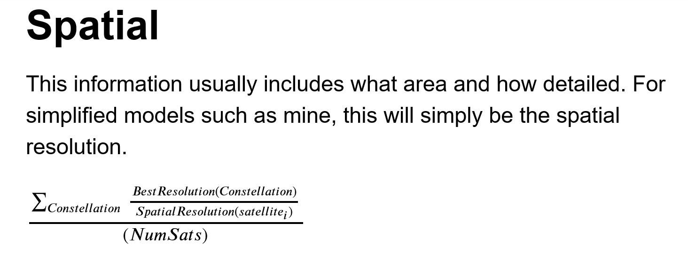

This first equation states that the main criterion for spatial information is the spatial resolution of the sensor. Furthermore, it takes an average across the constellation of the best resolution in the constellation over the specific resolution of each satellite in the constellation. Furthermore, this creates a distribution from zero to one of the spatial information capacities of a specific constellation.

Equation 2:: Binning Equation for Spectral Information

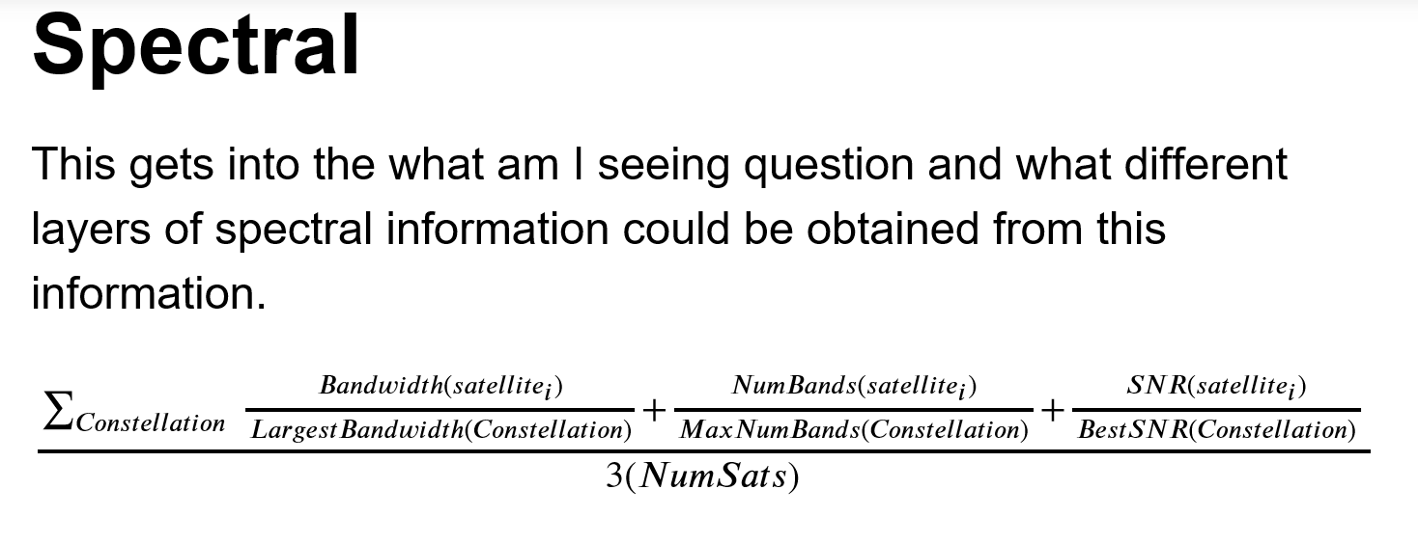

This second equation takes a similar approach averaging across the bandwidth of signals sensors, the number of bands of spectral sensors, and the sensitivity of the imager or signals satellites. This again creates a distribution from zero to one of the spectral information capacities of a specific constellation.

Equation 3:: Binning Equation for Temporal Information

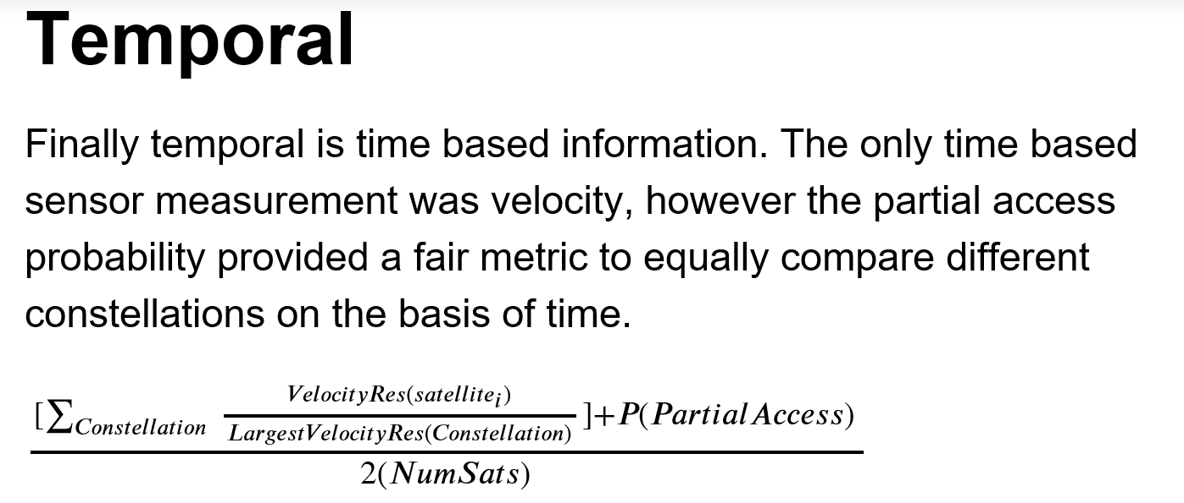

Finally, the temporal information is largely similar, the main metric in the data that captures temporal information is the probability of partial access, a metric intrinsically related to time. As this is a well-defined metric that already has a distribution from zero to one in the data, this is included in the Temporal Information metric. Additionally, some sensors can collect velocity information, another metric that would fall into the temporal category. Thus, the metric creates an average between these two properties of the constellation again ranging from zero to one.

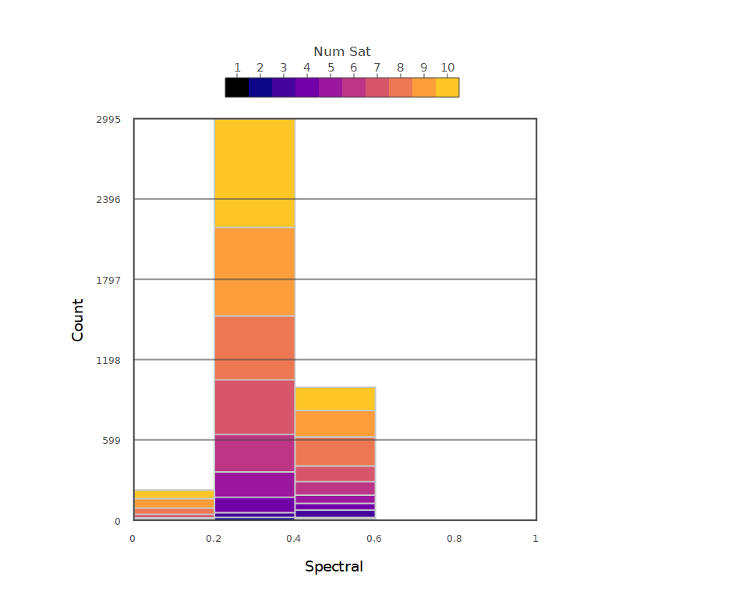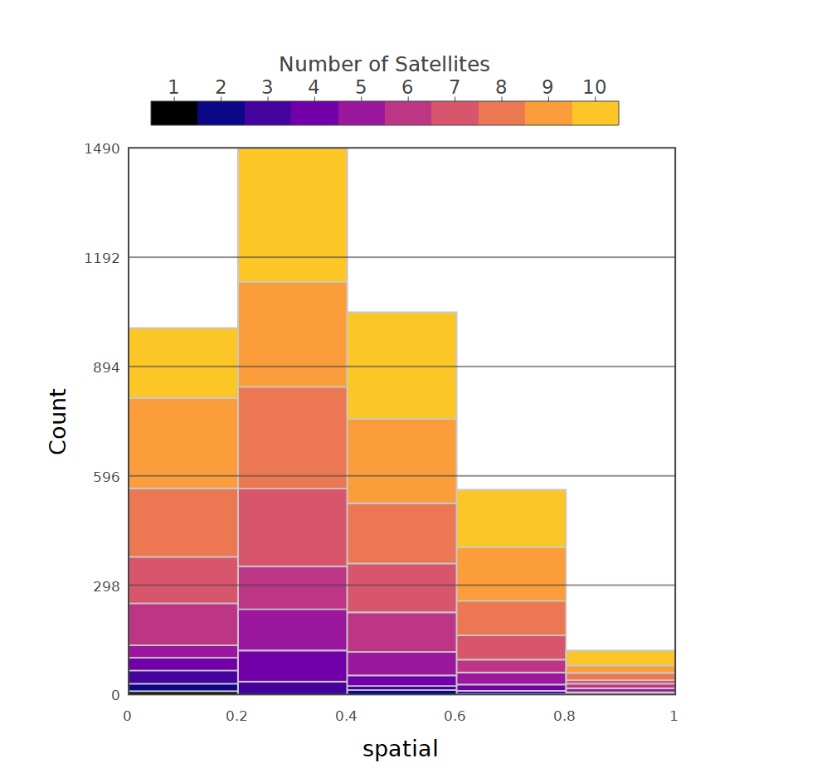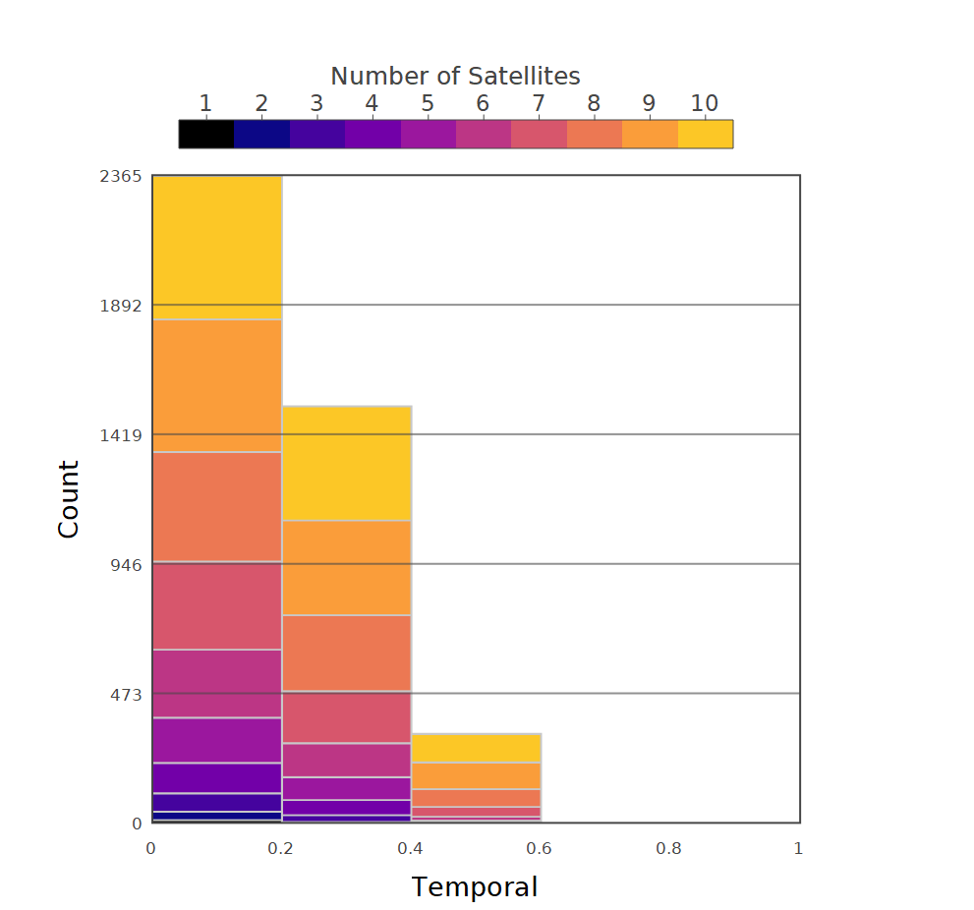 Once these equations were made, it was a simple matter of post processing the data and giving each constellation a spatial, spectral, and temporal metric. Once this was established, it was interesting to look, among the solutions that the genetic algorithm generated: looking to see if the information obtained leaned more in spatial, spectral, or temporal domains. This is encapsulated in the following histograms.

Figure 5: Spatial Histogram

Figure 6: Spectral Histogram

Figure 7: Temporal Histogram

A jarring part of this data is the wealth of spatial information and the lack of spectral and temporal information within the different bins. As previously mentioned, the spectral bin contains both the bands visual sensors observe and the bandwidth signals transmit across. However, the set of sensors included in the model contain no signals sensors. Thus, the genetic algorithm can only optimize among the spectral bands, effectively pulling the distribution to the left. Additionally, the temporal bin contains the velocity metric. However, there is only one sensor that can capture velocity. This again pulls most the data to the left within this distribution. Furthermore, these histograms confirm that the model is optimizing based on the sensors it was provided.

An interesting part of these histograms is that they bring one back to the fundamental question of how one compares information across sensor types. There is no ideal distribution that researchers would expect to see among these histograms. However, specific tasks could require different distributions of the information capacities in each one of these areas. Furthermore, if the target is very visual, with little spectral or temporal information, one might want to see figures like those above. On the other hand, it might be a target that contains a wealth of spectral information, and then you might want a different distribution.

This is the most important part about future research. If one can effectively create scenario’s that are encompassing of the problems faced today and, in the future, then a similar binning of solutions would show which type of information is more useful for evolving demands. However, this relies upon more complex and encompassing situations as well as refined metrics for this binning.

# Future Research

While this has been mentioned many times, it is necessary to emphasize the different avenues of future research as well as the decisions that must be made concerning Information Theory as a metric for future heterogeneous satellite constellations.

Starting with the latter, there are many concerns over the use of a metric like Harney’s as it neglects to account for the decay of information with time, neglects the advances in sensor systems since the paper’s inception, and does not capture the added value of a specific piece of information to a future timestep.

While some of these concerns have no obvious solution, there is something to be said about the Harney metrics in relation to the evolution of data science in the past 25 years. While it is not always true that having more units of information is better as the information could come with caveats, this was a harder view to reconcile when there was not an efficient way to sift through large amounts of data. However, unlike 25 years ago it is much more plausible today to analyze a large amount of information in a short amount of time with the continuing advances in processing, lending to the theory that any added information could be to an advantage.

This theory also becomes stronger when one considers the advances in prediction techniques in the past 25 years. Now there are neural networks that can find hidden patterns in data that often escape human comprehension. Additionally, although it is computationally heavy to train one of these networks, once they are trained they operate under a simple forward propagation algorithm which is effectively doing largescale linear algebra, something that has low computational complexity. Furthermore, with an increased ability to process large amounts of information and the prioritization of prediction methods that crave additional information metrics, Harney’s Information Theoretic approach makes assumptions that lend itself to the continuing advances in data science.

This is not to say that the problems mentioned previously are mute, but the underlying concepts in Harney’s metrics are becoming more valid. Thus, one should not completely scrap the idea of using similar metrics in the future, but instead take an approach like Harney that also accounts for information decay and could provide a method for seeing the effect that certain information has on observations at future timesteps, leading to a more dynamic architecture that better encompasses the goals of heterogeneous constellations.

As far as future research, the above should be prioritized. While it is important to increase scenario complexity and model complexity, these rely directly on the information metric at stake. It is once this metric is well established that models should be implemented, not the other way around.

Finally, with a clear metric established and a newly revised model, there is another avenue one could go with future research. This lies in defining observation thresholds related to the established information metric. Establishing threshold is similar to the research of Harney in defining the classification thresholds that different information levels provide in relation to the classic Johnson Criteria. For example, if I have 300 bits of Harney information what is the chance that I correctly classify something as a ship, a tank, or a car. Defining this threshold would be tantamount in establishing the minimum thresholds necessary for future heterogeneous constellations. This is something that is commonly done across each domain as it is why there are very focused satellites with very high resolutions as this is necessary for a certain level of classification. However, if one could properly define the levels necessary for a multi-int system it would allow researchers to demonstrate if there is a cost advantage in using such a system.

# Conclusions

Again, this research is in no way complete and has many caveats in its simplifying assumptions and the scenario used. With new research however, this is often the case. More important conclusions in new research come from better understanding of what the researchers do not understand. This is where the strengths of this project come to light. It highlights that there is a need for an objective method to compare intelligence systems. Additionally, once this is established, it is important to research the effect one piece of data has on a future timestep, possibly through data fusion methods such as Bayesian nets. This is tantamount if one wants to have an accurate model to assess the added knowledge of a specific piece of information. Finally, the project highlights a tradeoff that many tend to neglect with certain access metrics. While this tradeoff may be a result of a faulty problem formulation or a basic scenario, it is important to explore in the evolving world of information and data science.

# Works Cited

Ahmed, Mohiuddin, and Gregory Pottie. "Fusion in the context of information theory." *Distributed Sensor Networks* (2005): 419-436.

August, Peter, and Y. Q. Wang. “Resolutions of Remote Sensing.” University of Rhode Island, 2009.

Ferringer, Matthew P., Ronald S. Clifton, and Timothy G. Thompson. "Efficient and accurate evolutionary multi-objective optimization paradigms for satellite constellation design." *Journal of Spacecraft and Rockets* 44.3 (2007): 682-691.

Franklin, Steven E., and Clayton F. Blodgett. "An example of satellite multisensor data fusion." *Computers & Geosciences*19.4 (1993): 577-583.

Grönwall, Christina, et al. "Future electro-optical sensors and processing in urban operations." *Electro-Optical Remote Sensing, Photonic Technologies, and Applications VII; and Military Applications in Hyperspectral Imaging and High Spatial Resolution Sensing*. Vol. 8897. International Society for Optics and Photonics, 2013.

Harney, Robert C. "Information-based approach to performance estimation and requirements allocation in multisensory fusion for target recognition." *Optical Engineering*36 (1997).

Howerton, Phil. Managing Uncertainty and the Practice of Intelligence, [PowerPoint slides], 2019.

Jakob, Michal, et al. *Adversarial modeling and reasoning the maritime domain year 1 report.* Technical report, ATG, CTU, Prague, 2009.

Jakob, Michal, et al. *Adversarial modeling and reasoning the maritime domain year 2 report.* Technical report, ATG, CTU, Prague, 2009.

Liang, Shunlin. *Comprehensive Remote Sensing*. Elsevier., 2018.

L. Roux and J. Desachy, "Information fusion for supervised classification in a satellite image," *Proceedings of 1995 IEEE International Conference on Fuzzy Systems.*, Yokohama, Japan, 1995, pp. 1119-1124 vol.3.  
doi: 10.1109/FUZZY.1995.409823

“THE CEOS DATABASE : MISSION, INSTRUMENTS AND MEASUREMENTS.” *THE CEOS DATABASE : MISSION, INSTRUMENTS AND MEASUREMENTS*, 2019, database.eohandbook.com/.